**QA Report for Swift Swap**

The project entails developing a comprehensive trading website and mobile application designed to facilitate item exchanges without monetary transactions. Users will register and purchase memberships, granting them access to trade various items, with higher membership levels, unlocking the ability to trade more valuable goods.

The platform will include features such as user profiles, item listings, trade management, a messaging system, and a robust notification system. Advertisements will generate additional revenue. The website will be developed using React.js/Next.js for the front end and Node.js/Express.js for the back end, with MongoDB for database management.

The mobile application will be built using Flutter, ensuring seamless synchronization with the web platform. An admin dashboard will enable ancient management of users, items, and trades, alongside advanced analytics and reporting tools. Security features will ensure data protection and ongoing support will maintain platform integrity as the user base grows.

Here we need to identify and document any bugs, performance issues, functional issues, UI/UX issues. So, I will try to write a QA report for this Swift Swap Site:

There is a Google drive link for Test Case Writing Report:

<https://docs.google.com/spreadsheets/d/1THZ27Lf8CPVXhQRqBLIT3Bz9YSUntnCu/edit?usp=drive_link&ouid=117268842447131397510&rtpof=true&sd=true>

1. Core Features for this Website.

**Issues Description:** The pages listed in the client's requirements have not all been properly implemented on the website. As a result, there is an issue in the core features related to the page list.

**Steps to Reproduce:**

* Open site the home page
* Try accessing all listed pages.

**Screenshots:**



**Severity Level**: High

2. Membership System Not Displayed Properly:

**Issues Description:** Membership options (Gold, Platinum, Diamond) are missing or not displayed properly on the user profile. Their Membership options cannot work. Even after sending the request with all the information for approval, it shows as Awaiting Approval, so the membership system is not working.

**Steps to Reproduce:**

1. Log in with a valid user.
2. Go to the profile section.
3. Check for membership level/status UI

**Screenshots:**

**Severity Level**: High

3. Item Listing Functionality Not Working:

**Issues Description:**  Clicking “Add to Swap” does not show listing form or fails to save the item. Here can not Add to Swap Option because of membership problem.

**Steps to Reproduce:**

* Log In
* Click on “Add to Swap”.
* Send Request

**Screenshots:**

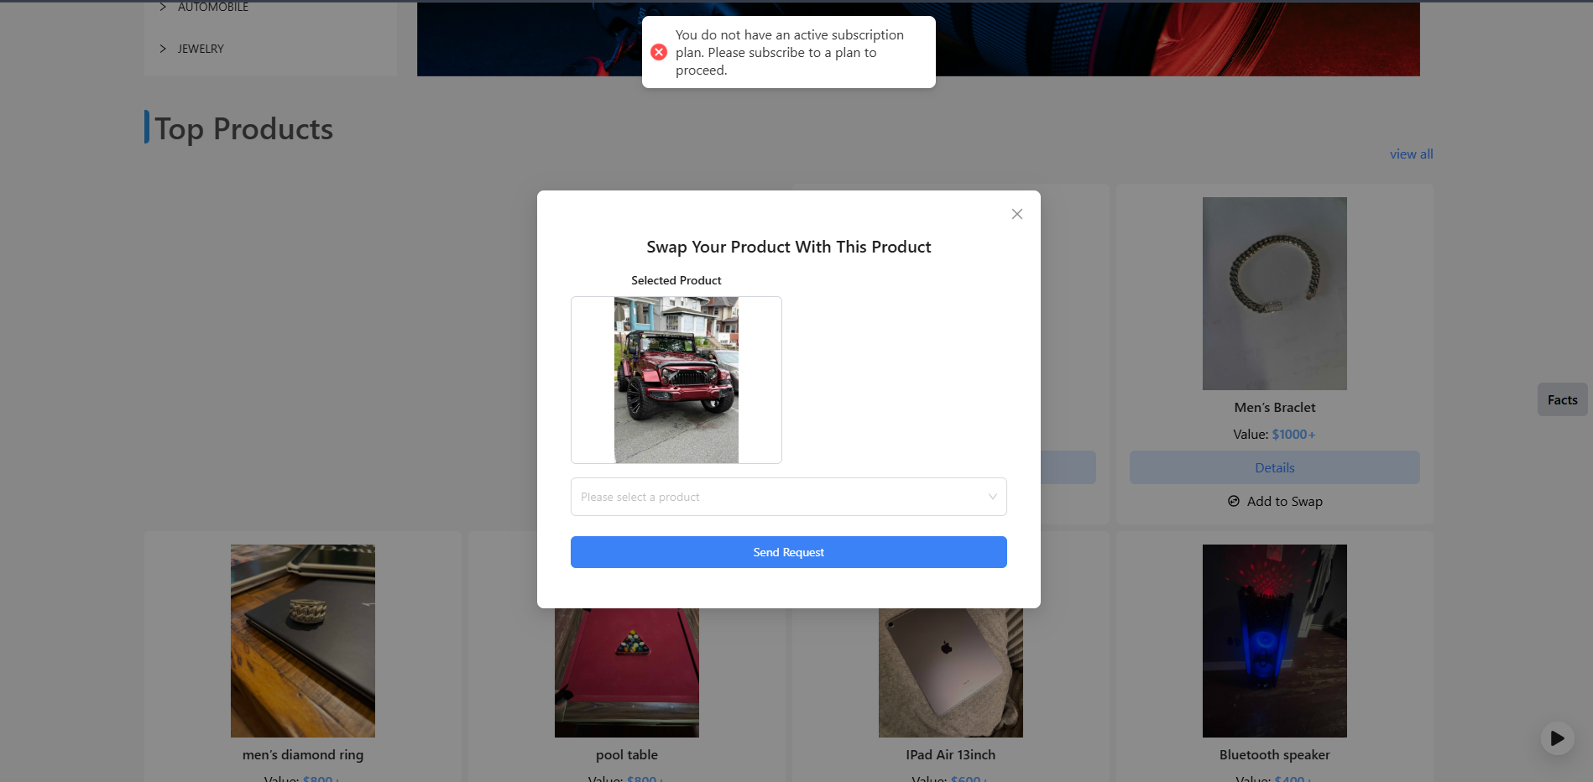

**Severity Level**: High

4. Website UI Problem:

**Issues Description:** There is no proper UI on this website. There’s an unnecessary gap below the "Top Products" section, and the images are not displaying correctly from the beginning.

**Steps to Reproduce:**

* Go the Login page
* See the full UI

**Screenshots:**

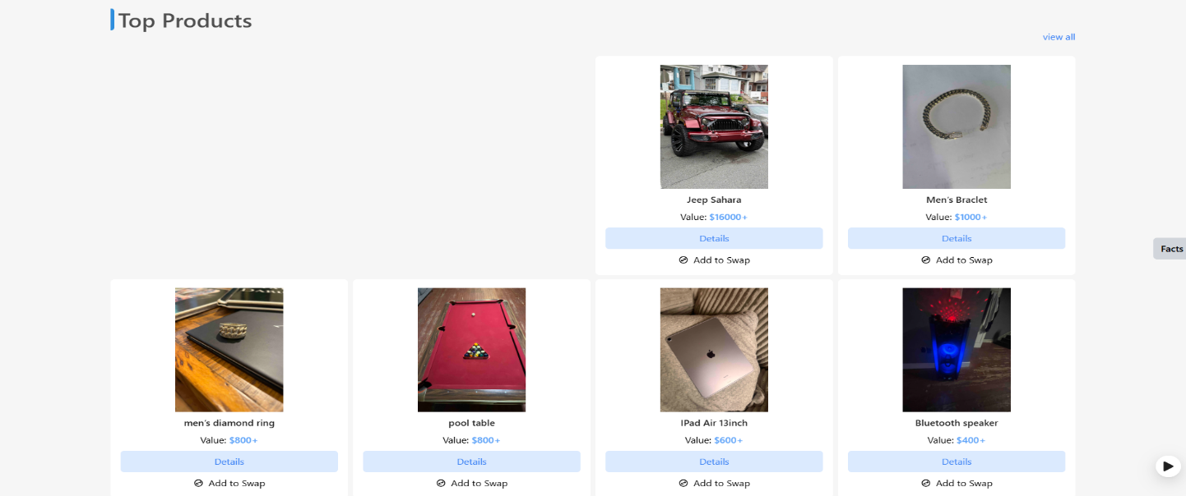

**Severity Level**: High

5. Trade Request Feature Unavailable:

**Issues Description:** No option available to request a trade for listed items.

**Steps to Reproduce:**

* Browse any item.
* Click “Request Trade”.
* Check if the trade request option exists.

**Screenshots:**

**Severity Level**: High

6. Messaging System Not Functional:

**Issues Description:** Chat window does not send or receive messages**.**

**Steps to Reproduce:**

* Log in and start a chat with another user.
* Try to send a message.

**Screenshots:**

**Severity Level**: High

7. Reports and Analytics Missing:

**Issues Description: N**o analytics dashboard or user activity reports visible.

**Steps to Reproduce:**

* Try accessing reports under admin or profile section.

**Screenshots:**

**Severity Level**: High

8. Admin Dashboard Unavailable:

**Issues Description:** Admin panel is not accessible; no admin login or dashboard page found.

**Steps to Reproduce:**

* Attempt to locate admin login via URL or link.

**Screenshots:**

**Severity Level**: High

9. Customer Support Not Functional:

**Issues Description:** No support page, contact form, or help center available.

**Steps to Reproduce:**

* Scroll to footer or menu and look for “Support” or “Contact Us”.

**Screenshots:**

**Severity Level**: High

10. Payment Integration Not Found:

**Issues Description:** Payment gateway or subscription payment functionality missing.

**Steps to Reproduce:**

* Go to any premium/membership area.
* Look for payment or subscription options.

**Screenshots:**

**Severity Level**: High

11. Search & Filters Not Visible:

**Issues Description:** Search input or filter categories not implemented on homepage.

**Steps to Reproduce:**

* Navigate to homepage.
* Look for item/category search bar.

**Screenshots:**

**Severity Level**: High

12. Language Switch Missing:

**Issues Description:** Here option to switch between English and Spanish can not work properly. When Spanish is selected, only some parts of the header's navbar change and footer, but the rest of the content remains in English.

**Steps to Reproduce:**

* Scroll to header/footer.
* Look for language selector.

**Screenshots:**

**Severity Level**: High

13. Home page Categories Section:

**Issues Description:** In the Categories section of the homepage, most of the subsections appear empty. There is no data in most of the subsections.

**Steps to Reproduce:**

* Go to the home page
* Click to Categories section

**Screenshots:**

**Severity Level**: High

14. See the Tutorial:

**Issues Description:** The Tutorial section on the homepage doesn’t contains any tutorials.

**Steps to Reproduce:**

* Go to the home page.
* Click the Tutorial section.

**Screenshots:**

**Severity Level**: Medium

So, here is a summary including issue descriptions, steps to reproduce, screenshots for each problem, and severity levels. This website does not fulfil the given requirements—most of the requirements are missing.

The site contains numerous bugs, including both functional issues and UI/UX problems. There is a lot of room for improvement in many areas of the website.